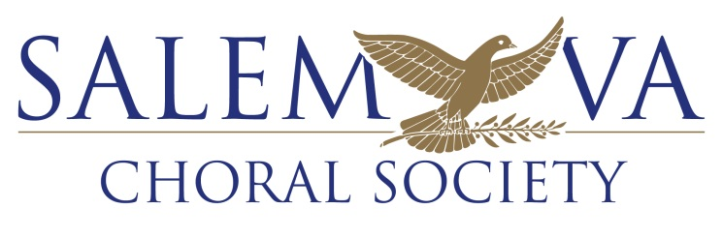
The Official Chorus of The City of Salem

The Salem Choral Society remains dedicated to providing quality music for community events and we strive to provide civic support through innovative musical outreach. We are a non-profit organization and are able to provide choral concerts for our community because of the support of our generous patrons. Any donation, regardless of size, is crucial for us to continue to bring engaging performances to our community.
The Salem Choral Society is an IRS Section 501 (c)(3) non-profit organization. Your donations supporting the chorus are tax-deductible.

Please include this form with your donation, thank you!

NAME: ___________________________________________________________________________________
ADDRESS: _________________________________________________________________________________
PHONE NUMBER: ______________________________
CHECK ENCLOSED FOR $____________________
MAKE CHECKS PAYABLE TO: The Salem Choral Society, Inc.
MAIL THIS FORM AND YOUR CHECK TO: The Salem Choral Society, Inc.
P.O. Box 350
Salem, VA 24153

